Software Design Document

Security in Internet of Things Devices

Kai Tindall

k.tindall-2018@hull.ac.uk

Abstract

This document will outline the design of the software to be developed in the project.

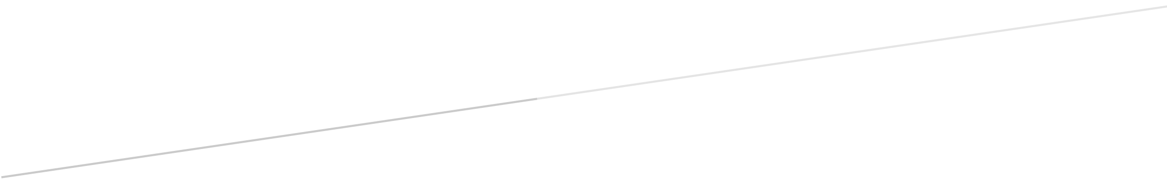

Table of Contents

1.1 Revision History 2

1.2 Document References 2

1.3 Acronyms 2

1.4 Glossary 2

2 Heading 3

## Revision History

|  |  |  |  |
| --- | --- | --- | --- |
| **Version Number** | **Date** | **Author** | **Comment** |
| 1.0 | 28/11/2020 | Kai Tindall | Initial draft of the document |
|  |  |  |  |
|  |  |  |  |

## Document References

|  |  |  |  |
| --- | --- | --- | --- |
| **Identification Number** | **Description** | **Version** | **Reference Number** |
|  |  |  |  |
|  |  |  |  |
|  |  |  |  |

## Acronyms

|  |  |
| --- | --- |
| **Acronym** | **Definition** |
|  |  |
|  |  |
|  |  |
|  |  |
|  |  |
|  |  |

## Glossary

|  |  |
| --- | --- |
| **Word** | **Definition** |
|  |  |
|  |  |
|  |  |

# Heading